

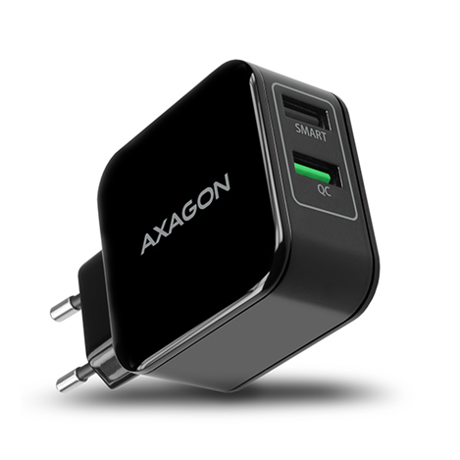

**INPUT**

**∙** connector two-pin EURO fork

**∙** compatibility 100 - 240V AC, 50/60Hz

**OUTPUT**

**∙** output power 5V/2.8A, 9V/2A, 12V/1.5A (QC3.0) + 2.6A / 5V

**∙** connector 2x USB Type A female

**SUPPORTED FEATURES**

**∙** charging 2 devices at the same time yes

**∙** Standard charging yes (5V /1A)

**∙** Smart charging yes (5V /2.6A)

**∙** USB Battery Charging 1.2 yes  
**∙** Qualcomm Quick Charge 1.0 yes  
**∙** Qualcomm Quick Charge 2.0 yes

**∙** Qualcomm Quick Charge 3.0 yes

**∙** Samsung Adaptive Fast Charging yes

**∙** Huawei Fast Charge Protocol yes

**∙** MediaTek Pump Express+ yes

**∙** MediaTek Pump Express+ yes

**∙** overload protection yes

**∙** short circuit protection yes

**∙** protection against voltage spikes yes

**∙** protection against overheating yes

**OTHER FEATURES**

**∙** dimensions 91 x 53 x 29 mm (including the fork)

**∙** weight 90 g

**WWW.AXAGON.EU**

**PN:** ACU-QC5  
**EAN:** 8595247904096

Universal **AXAGON ACU-QC5** mains USB charger to quickly charge up to two mobile devices at a time. With 31 W of total power, the charger recharges both mobile phones and tablets at the highest possible speed. Two independent USB outputs Quick Charge 3.0 and SMART 5 V/2.6 A allow fast charging of most mobile devices. It is compatible with Apple iPhone, iPad, Samsung, Huawei, Honor, HTC, Xiaomi, LG, Motorola and other fast charging standards.

The Quick Charge 3.0 technology allows up to 4 times faster charging of supported devices than a conventional USB charger. The AIC function recognizes the connected device and automatically selects the optimal charging speed, while the CV/CC function ensures steady course of charging. The advanced protection system at the charging adapter output protects the device being charged from damage.

The USB charger indicates the correct input power with a blue LED built inside, its light does not disturb and does not distract you. The body of the power adapter has a pleasant shape and size, true handy helper at home as well as on the road

AXAGON ACU-QC5

QUICK and SMART WALL CHARGER